Algebra 2: Rational Equations and Functions Introduction
Name: _____________________________________________ Date: ________________________________
FIND THE PUNCHLINE BY SOLVING THE MULTIPLE CHOICE QUESTIONS
Directions: Find the solution for the questions. Each question has a correct answer. Write down the letter that corresponds to the right answer. When you have all the 23 letters, read them and you will have the punch line.

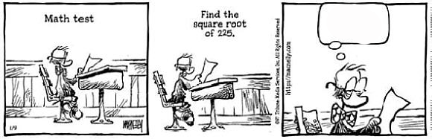

DO NOT WRITE ON THE SHEET GIVEN TO YOU!

1.
A: M: T: I:

2.
E: D: A: T:

3.
I: S: T: B:

4.
D: C: M: L:

5.
I: N: E: P:
6.
A: I: S: O:

7.
T: and P: and
R: and Z: and

8.
N: M: K: T:

9.
N: not a real number O: U: V:

10.
E: A: C: O:

11.
W: B:
S: T:

12.
C: K: I: L:

13. Which number is a perfect square?
A: 124 T: 64 V: 46 N: 48

14.
Y: T: W: P:

15. . Then
A: 4 B: 16 D: -4 F: -16

16.
F: S:
M: R:

17. Which number is a perfect square?
N: P: M: T:

18.
I: A: B: D:

19.
V: Y:
F: S:
20.

21.
E: A: C: I:

22.
G: N: H: M:

23. Then

P: 5 G: 6 R: -5 V: -6

