**pH Levels and Logarithmic Functions Experiment**

**Group Members Names: ____________________________________________________________________**

**Step One: Obtain all materials needed (pH Paper x 10, Worksheet, Calculator)**

**Step Two: Go to each station set up around the room and use the pH paper to determine the pH level of the item at that station. (Make sure to number your pH papers with the corresponding numbers in the chart and turn them in as well as this worksheet when completed.) Fill in the chart below with the pH paper color and corresponding pH level.**

**Step Three: Once completed with all the stations, get into your group and figure out the possible Hydrogen Ion concentrations of the items measured as well as whether that item would be classified as an acid or a base and whether it’s a weak/strong acid/base. Make sure to write down ALL your calculations and turn them in with this sheet!**

**Step Four: Complete as a group the critical thinking questions below the table.**

**Helpful pH formula: pH = - log [H+] where [H+] means the hydrogen ion concentration**

|  |  |  |  |  |  |
| --- | --- | --- | --- | --- | --- |
| **Item** | **pH Paper Color** | **Corresponding pH Level** | **[H+]** | **[OH-]** | **Acid/ Base? Weak/ Strong?** |
| 1. **Distilled Water** |  |  |  |  |  |
| 1. **Tap Water** |  |  |  |  |  |
| 1. **Rain Water** |  |  |  |  |  |
| 1. **Soda** |  |  |  |  |  |
| 1. **Red Wine Vinegar** |  |  |  |  |  |
| 1. **Lemon Juice** |  |  |  |  |  |
| 1. **Baking Soda** |  |  |  |  |  |
| 1. **Aspirin (in water)** |  |  |  |  |  |
| 1. **Shampoo** |  |  |  |  |  |
| 1. **Soap** |  |  |  |  |  |

**Discussion Questions:**

1. **From your experiments chart the solutions you measured on the pH chart below. Also fill which side is acidic, neutral, and basic as well as which are the weak/strong acid/bases.**

[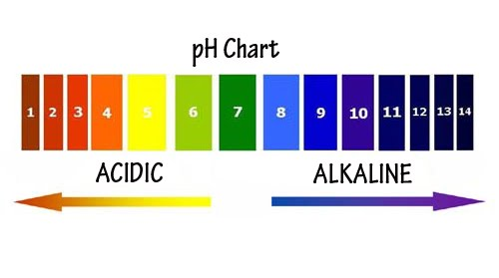](http://www.google.com/url?sa=i&rct=j&q=&esrc=s&frm=1&source=images&cd=&cad=rja&docid=MLPYZYNJTpAkDM&tbnid=ZPR6nV1-zOaO8M:&ved=&url=http://www.thewellnesswarrior.com.au/2010/05/dropping-acid/&ei=6wNsUYTTAcWT2gX7loCACg&bvm=bv.45175338,d.b2I&psig=AFQjCNGGRqQSwnM73b-ScBfmK9DVxh7nfw&ust=1366119787409540)

1. **From our conversations about how pH levels are found, choose one acid and one base from the list of experimented solutions and explain what is happening with the ionization of water and why this would lead to the results you have found. Then calculate the number of times stronger it is than the other one you have chosen.**
2. **By increasing the number of H+ ions in a solution what would happen to the pH of that solution? How do you know?**
3. **By decreasing the number of H+ ions in a solution what would happen to the pH of that solution? How do you know?**
4. **What is the other formula you could use to determine the pH of a solution?**
5. **In a neutral solution, what should the level of H+ ions equal? How do you know this, and logically why should this happen?**